

**Immediate Needs**

**Girl’s winter clothes sizes 6T, 7T, 8T**

**Boy’s winter clothes sizes 6T, 7T, 8T**

**Size 1 & 2 diapers**

**Meats – ham, chicken, beef, turkey, deli meats**

**Perishable Food Items**  
Eggs

Fresh fruits and vegetables  
2% and whole milk  
Cheese & cheese sticks

Shredded cheese

Chicken nuggets

Tatertots, French fries

**Seasonal Requests**

Winter:

* Kids winter boots
* Blankets
* Christmas cookie mix/decorations
* Ice melt (for sidewalks)
* Holiday decorations
* Humidifier

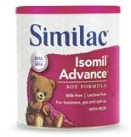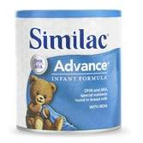**Formula – all kinds appreciated!**Similac AdvancedSimilac Isomil

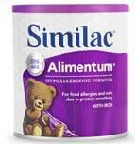Similac Alimentum Enfamil Enfacare

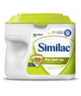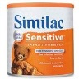Similac Sensitive Similac for Spit-up

Enfamil ProSobee Gerber Good Start Gentle

****Gerber Good Start Soy Gerber Good Start Supplemental

**Gift Cards**Rosauers Yokes   
Safeway WalMart  
Costco Babies ‘R Us  
Target Fred Meyer   
Home Depot Bed, Bath and Lowes Beyond

**Diapers**  
All sizes (especially 1 & 2)  
Pull-ups: all sizes  
Baby Wipes

C:\Users\mmcconnaughey\AppData\Local\Microsoft\Windows\Temporary Internet Files\Content.IE5\0KLQ2BUP\MC900088936[1].wmf

*The Vanessa Behan Crisis Nursery depends on donations from the community to help us provide safe shelter for our children*