

**Immediate Needs:**

**Enfamil Enfacare 12.4 oz  
Enfamil Nutramigen 12.6 oz**

**Size 5 & 6 diapers!**

**Pull-Ups: All sizes!**

**Non-Perishable Food Items**  
Jars of baby food-1sts, & 3rds

Juice/juice boxes

Kix, cornflakes, rice krispies

Canned fruits

Crackers

**Perishable Food Items**  
Eggs

Yogurt

Fresh fruits and vegetables  
2% and whole milk  
Cheese & cheese sticks  
Margarine or butter  
Ground Beef  
Chicken

Chicken nuggets

Deli meat – ham, turkey

Bread (Wheat, white or potato)

Bagels, English Muffins

Frozen Pizza, burritos

Tater tots, French fries

**Household Items**

**Tri-Fold paper towels**

**Toilet paper**

**Pine Sol**Garbage liners (33 and 55 gallon)

Toys (new)   
 **Office Supplies**

Scotch tape

**Seasonal Requests**

Summertime- Outdoor toys and cleaning products

* Bubbles, sidewalk chalk, playground balls
* Water toys
* Scooters, bikes
* Swim suits, up to size 10
* Boys 4T Summer Clothes
* Blankets
* Bottles (new)

Staples  
Copy paper (8½ x 11)

*The Vanessa Behan Crisis Nursery depends on donations from the community to help us provide safe shelter for our children.*

**Formula – all kinds appreciated!**Similac AdvancedSimilac Isomil 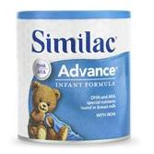 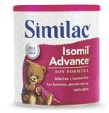

Similac Alimentum Enfamil Enfacare  
 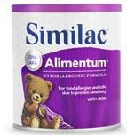 

Similac Sensitive Similac for Spit-up  
 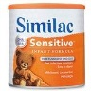 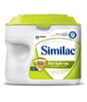

Enfamil Gentlease Enfamil ProSobee  
  
 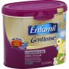 

**Gift Cards**Rosauers Yokes   
Safeway WalMart  
Costco Babies ‘R Us  
Target Fred Meyer   
Home Depot Bed, Bath and Lowes Beyond

C:\Users\mmcconnaughey\AppData\Local\Microsoft\Windows\Temporary Internet Files\Content.IE5\0KLQ2BUP\MC900088936[1].wmf**Clothing**  
New clothing (Birth – size 10, especially sizes 3T and up)

**Diapers**  
Sizes 5 & 6  
Pull-ups: all sizes  
Baby Wipes